**ECON 136: Week 7, Wednesday**

**Positive Externalities and Public Goods**

A) The Inefficiency of Positive Externalities

Externalities arise when the competitive market model assumption of excludability is violated so that the transaction between buyer and seller imposes costs or benefits on third parties.

A **negative externality** imposes costs on third parties not borne by the buyer or seller so that

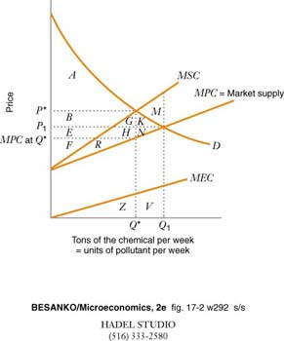MSC = MPC +MEC

and the market outcome is greater than the economically efficient outcome that just balances incremental benefits with incremental costs (including the external cost).

A **positive externality** benefits third parties without compensating buyer or seller so that

MSB = MPB + MEB, where MEB is the marginal external benefit.

Now, the market produces too little of the good.

As always, we represent the resulting inefficiency (deadweight loss) of a deviation from the socially optimal outcome as the area between

Market output (Q1) and socially desired output (Q*); and

Marginal social cost (S) and marginal social benefit

B) Examples of Nonexcludable Goods that Generate Positive Externalities

C) Public Goods

1) Public goods violate both the excludability and the assumption that there is rivalry in consumption – that my purchasing the good eliminates its availability in the market place.

Classic examples of nonexcludable and nonrivalrous, hence, public goods:

Fireworks displays

A 19th century light house

Clean Air

2) Categorizing Goods

In each case is the product nonexcludable, nonrivalrous, both or neither

Satellite TV programming

An ice cream sundae

Salmon off the coast of Maine

Cattle on John’s farm

A Bryn Mawr education

Getting the flu vaccine

3) The inefficiency of public goods

Imagine two neighbors who would benefit from preserving a wooded land between them. Since enjoyment of the open space vistas is nonexcludable, each benefits. Since one’s enjoyment doesn’t prevent the other from enjoying it, it is nonrivalrous. The benefit to society of any given level of open space is the sum of the **value** to each neighbor. Hence, we add their individual demand curves **vertically** to derive the market demand.

As with all positive externalities, too little of the public good is produced.

4) Important classes of public goods include

--responding to negative externalities.

Reducing pollution

Noise barriers on highways

--addressing the consequences of other market failures

Eliminating Poverty

Reducing crime

--responding to positive externalities

Maintaining local roads

Education

Responding to chronic homelessness

Protecting endangered species

5) The case for government providing most public goods ought to be a no brainer:

D) Problems

1) (From Monday): Suppose the demand for oil is given by PD = 90 – 0.5Q in millions of barrels and that the marginal private cost of producing oil is PS = 10 + 0.3Q. A toxic byproduct of oil drilling causes a marginal external cost of 0.2Q. Draw an appropriate diagram to illustrate and use algebra to confirm that

a) the market equilibrium will yield 100 million barrels of oil at a price of $40/barrel;

b) the socially efficient (MSC = MSB) output is 80 million barrels

c) the deadweight loss associated with the market equilibrium is $200 million.

2) Suppose there are 3 consumers of a public good

MB1 = 60 – Q

MB2 = 100 – Q

MB3 = 140 – Q

Carefully draw the diagram showing that

MSB = 300 – 3Q, for Q < 60

240 – 2Q, for 60 < Q < 100

140 – Q, for 100 < Q < 140

If MC = 180, confirm that the socially optimal level of the public good is Q = 40.